**A1Wb Frequency Polygon**

A **frequency polygon** is another way to show the information in a frequency table. It looks a little bit like a line graph. To make a frequency polygon, you just need to plot a few points and then join the points by straight lines. So, what points do you need to plot? Well, first you have to find the midpoints of each class. The **midpoint of a class** is the point in the middle of the class. The class mid-points of the first and last class are joined to the x-axis to either side at a distance equal to (1/2)th the class interval of the first and last class.

Mid-point of class =  (1)

Where UCB=Upper Class Boundary and LCB=Lower Class Boundary.

**Example**

Table 1 illustrates the frequency polygon for Example 1 data set.

|  |  |  |  |
| --- | --- | --- | --- |
| Class | True limits | Class mid-point | Frequency |
| 400 - 419 | 399.5 - 419 | 409.5 | 11 |
| 420 - 439 | 419.5 - 439.5 | 429.5 | 23 |
| 440 - 459 | 439.5 - 459.5 | 449.5 | 30 |
| 460 - 479 | 459.5 - 479.5 | 469.5 | 21 |
| 480 - 499 | 479.5 - 499.5 | 489.5 | 13 |

Table 1

Figure 1 illustrates the frequency polygon for the travelling truck problem.

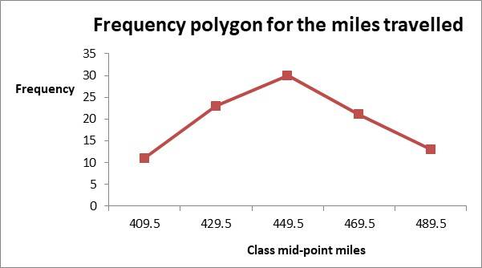

Figure 1

**Excel solution**

Step 1 Data Series

Class Mid-Point: cells D3:D8 (includes data label)

Frequency: cells E3:E8 (includes data label)

Highlight cells D3:E8

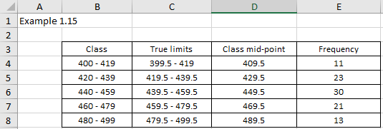

Figure 2

Step 2 Select Insert > Line or Area Chart > select option 4 as illustrated in Figure 3

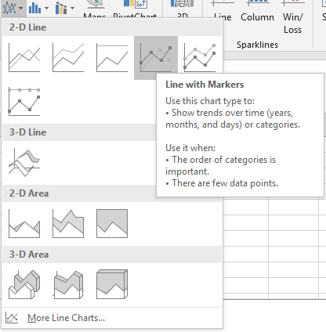

Figure 3

This will result in the graph illustrated in Figure 4

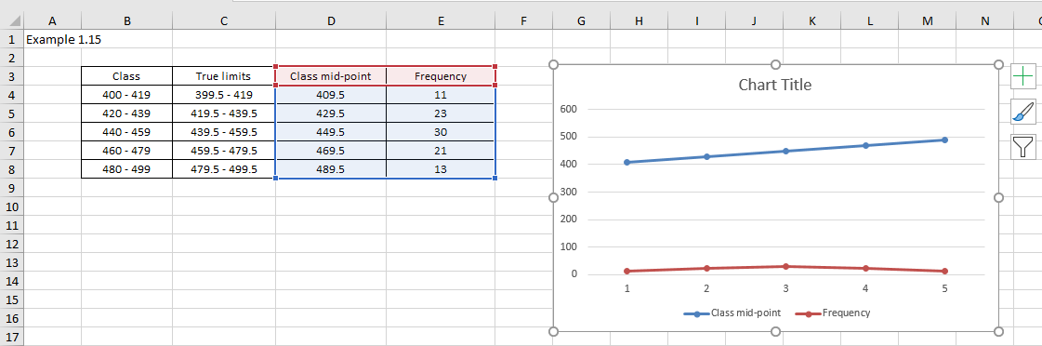

Figure 4

Step 3 Edit the chart

From Figure 4, we note that we have two lines on the chart: class mid-point line, and frequency line. Click on the blue class mid-point line and press delete on the computer keyboard. The chart illustrated in Figure 4 will now change to the chart illustrated in Figure 5.

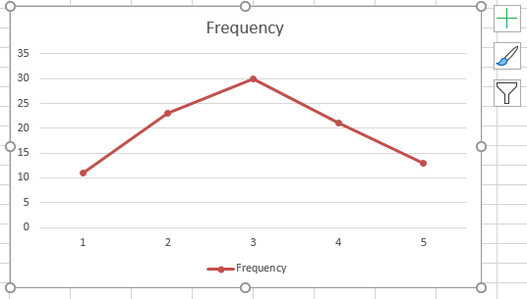

Figure 5

The chart is correct on the vertical axis (frequency) but we would like the horizontal axis to use the class labels rather than the numbers 1, 2, 3, 4, 5, and 6. To modify the horizontal axis label from these numbers to the class mid-point labels we need to edit the data series. Right-click on the data line as illustrated in Figure 6.

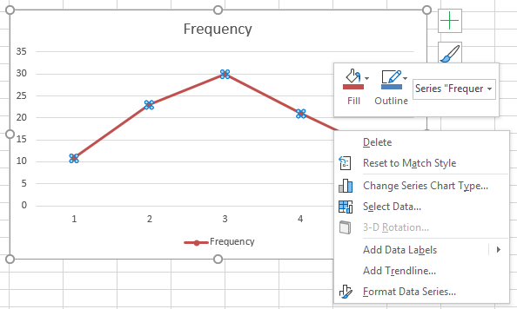

Figure 6

Choose Select Data (see Figure 7).

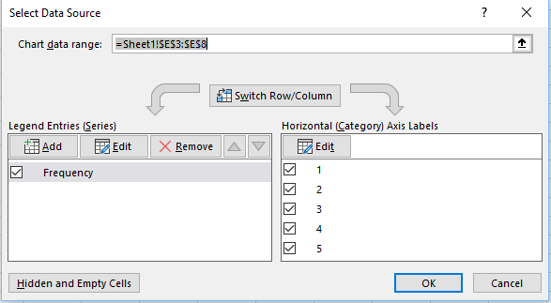

Figure 7

Click on Edit in the Horizontal (Category) Axis Labels and browse to the class mid-point cell reference (D4:D8)(see Figure 8).

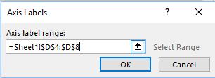

Figure 8

Click OK

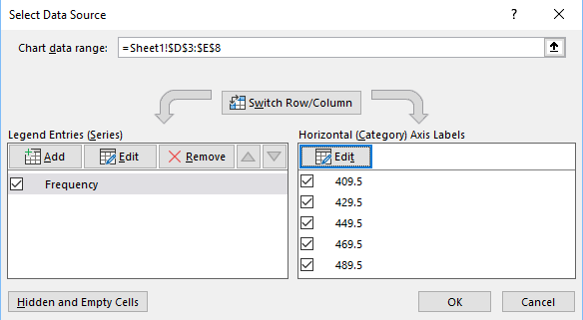

Figure 9

Click OK and the chart will be modified as illustrated in Figure 10

Figure 10 illustrates the frequency polygon after a degree of reformatting (removed border, horizontal gridlines).

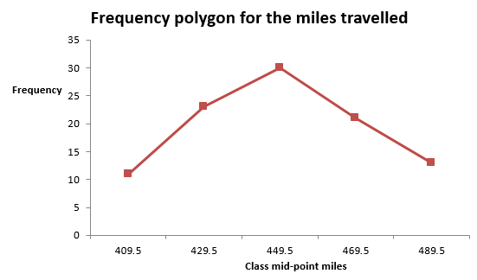

Figure 10

### Check your understanding

X1 Create a frequency polygon (line graph) for the data in Table 2.

|  |  |
| --- | --- |
| Age (years) | Frequency (1000's) |
| 16-17 | 4 |
| 18-20 | 73 |
| 21-24 | 185 |
| 25-29 | 104 |
| 30-34 | 34 |
| 35-39 | 33 |
| 40-44 | 22 |
| 45-54 | 10 |
| 55 and over | 26 |

Table 2

X2 Table 3 illustrates the time taken by a student to complete a one question test in mathematics.

|  |  |
| --- | --- |
| Time, t (seconds) | Frequency |
| 0 < t ≤ 10 | 1 |
| 10 < t ≤ 20 | 2 |
| 20 < t ≤ 30 | 8 |
| 30 < t ≤ 40 | 12 |
| 40 < t ≤ 50 | 6 |
| 50 < t ≤ 60 | 3 |

Table 3

(a) Construct a histogram to represent this data.

(b) Construct a frequency polygon to represent this data.